1. **Business Requirements:**

**Develop an online renting of equipment system:-** A club want to rent its equipment’s to members. There could be around couple hundred items with a unique serial numbers. These equipment’s can be ‘checked out’ and ‘checked in’ by members. Each of the equipment may be part of a Set - or not. If a member check out a Set all the equipment’s that are part of it comes along with it. Members are supposed to check whether all items are present (which are supposed to be there as part of the package). If not, they should refuse it. Once the equipment or Set is checked out, they can check in once they are done with it. A member can check out only one Set at a time. Members are also part of a “Group”. All groups have a lead who is a member too. If they check out as a group, the lead is responsible to check out the item. One group cannot check out more than one Set at a time. Club operate only at certain times , ie opening days, times. All members should be present in the club while using equipment and return it before close of club. An administrator is verifying if all items are present before close of the day. All members will initially do a deposit amount and monthly dues to the club.

There are two types of screens Admin module: Where admin users enter and manage a database of equipment’s, Club timings, members, groups etc. Groups and members of the groups will be entered. Equipment’s and packages will also be entered. Once if the equipment is entered as a package, it is not used as an individual item or part of another package. Some equipment’s or packages has time limit on how long it can be checked out by same team. Day to Day operators: Club volunteers: Helps to check out and check in equipment on a day to day basis. The software should check for timeout every 10 minutes and give alarms if somebody is reaching their time limit on checked out equipment’s.

Develop software application using Python for this. The intention is to teach the database libraries of python. Feel free to use an architecture like flask etc… Anything which is not database related can use simple methods. Like webforms or html etc for front end..

1. **Business Processes**
2. **Club Manager Processes**

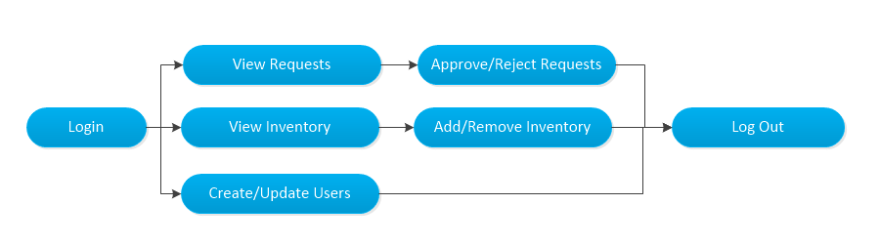

1. **Club Member Processes**

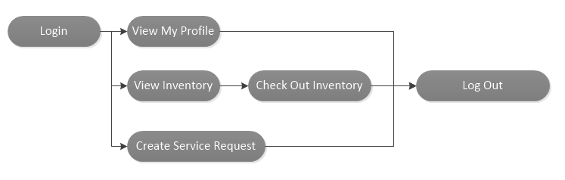

1. **Use Cases**
2. **Overall Application Architecture**

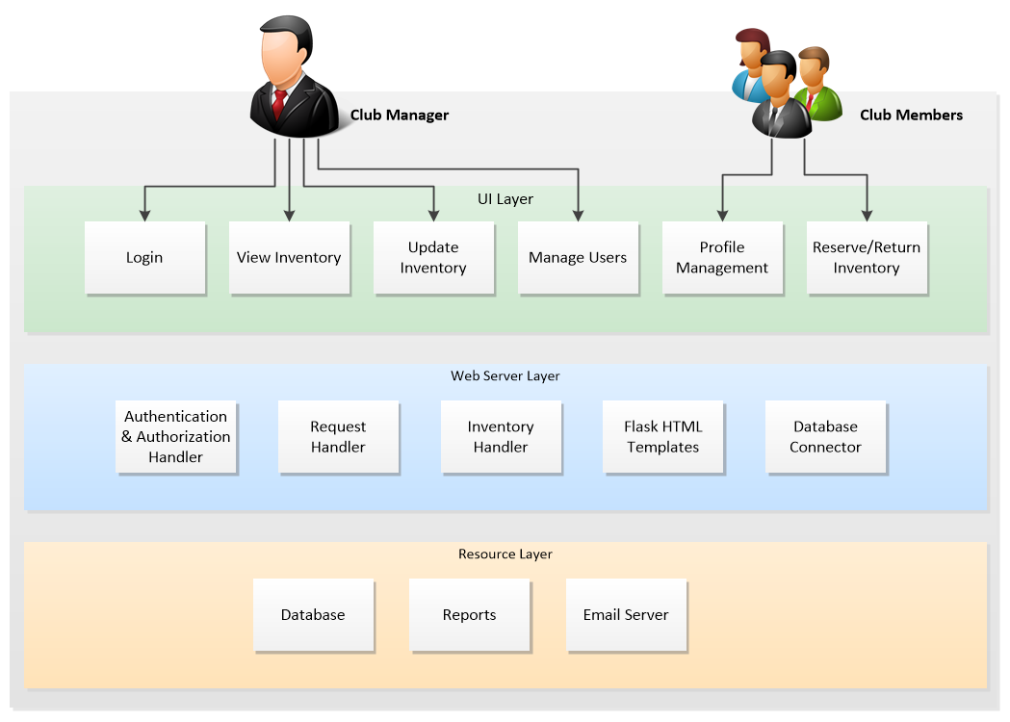

1. **Technology Architecture**

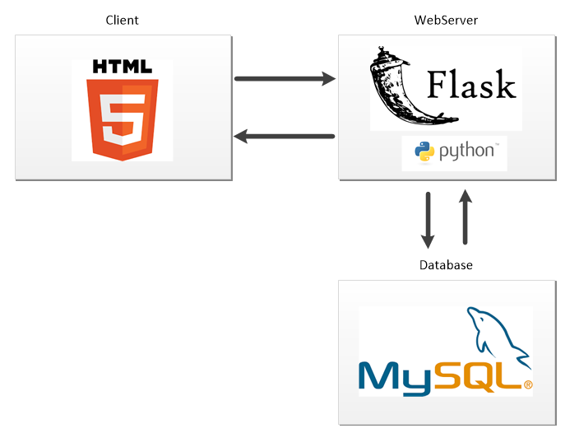

1. **Architecture Components**

* UI Component
* Web Server
* Database components (Description of each component)
* …………..

1. **UI Page Design**
2. **Project Management:**

* Multiple Releasees, Requirements delivered for each release.
* Five Releases.

**Club Manager Processes**

1. Equipment Management and Package (Set of Equipment’s) Management [Release 1]
2. Member and Group list management [Release 2]
3. Club Daily Stock management (Evening Check of Stock Daily)[Release 1]
4. Club Operational Hours Maintenance. [Release 2]
5. Monitoring timeout alarms for checked out items. [Release 4]
6. **Club Member Processes**
7. **Renting and Returning equipment’s [ Release 3]**
8. Ensuring the package checked out has all equipment’s while checking out and returning it.[Release 5]
9. **Test Strategy**